Virtual Machine Migration

Aastha Jain (014868722)

Atul Gupta (014882528)

ABSTRACT— A Virtual machine is a software computer that runs operating system and applications like a physical computer. The platform used for running virtual machines is known as hypervisor. The procedure of moving a virtual machine from one host to another host is known as migration. Why Migration is required? It overcomes various limitations such as lower the downtime of server, while scheduled maintenance of host. Virtual machine can be migrated to some other server and can brought back to host after maintenance has been completed. This also provides a provision for migrating operating system from old servers to new servers and helps in optimization of load and power consumption.

The existing live migration technique for migration VM from one host to another host is beneficial as it reduces amount of transferred memory data which greatly increases performance. Hence we used technique pre-copy, post-copy and log/replay for one-to-one migration but it has a major drawback which is overloading the destination host, hence downgraded in the global performance of virtual machine services and eventually crashing the destination host.
The paper will describe, novel approach that can be adopted for migrating VM from one source host to many target hosts (simultaneously), known as VMscatter. VMscatter uses multicast approach to deliver identical pages to many hosts simultaneously and this reduces the network traffic as well minimize the overhead between multicast groups. In traditional migration approach eviction time (i.e. time to eject the state of one or many VM from the source host, eviction time will determine how quickly the resources can be repurposed to other hosts) equals to the full migration time ,on the grounds that, source is fixed until the destination terminal get hold of the entire VM. But with VMscatter, it dissociates the source and destination to reduce the eviction time when destination host is slow (i.e. due to insufficient memory or network bandwidth). In contrast to traditional migration process, VMscatter is able to reduce data transferred up to 74% and helps in reducing network traffic from 50.1% to 70.3%.

Keywords— Migration, VM, Eviction-time, VMscatter, Hypervisor, Bandwidth

- Introduction
The concept of virtualization has its origin in mainframe day in the late 1970s, when processing power, computing cost, and time-sharing resources were quite expensive. Then Virtual Machine Monitor (VMM) or hypervisor came into existence, which enables multiple operating systems to run on a single host computer. Hence, multiple instances of same operating systems or different operating systems can share hardware resources offered by the host. Virtualization improved resource utilization, maximized Uptime, ease of migration, consolidation of data and protected applications from server failure. Virtualization refers to creating virtual (rather than actual) versions of device or resource, such as operating system, servers, and storage device and network resources. Operating system virtualization is the handling of software to allow a portion of hardware to run multiple operating systems at the same time. Was originally defined as duplication of real machines.
Oracle Virtual Machine(VM) is a platform that enables users to deploy operating systems and application software as well as perform live migration of Virtual Machine by VM Manager .Oracle VM support networking and storage, load balancing and power management.

A Virtual Machine runs in one of three domains i.e. storage, network, and server virtualization. Storage virtualization means pooling of the physical storage from multiple storage devices into a virtually created single storage device, which is managed from central hub. Network virtualization is done in order to improve productivity by combining the resources in a network, then split bandwidth into channels and finally assign each of them to a particular server or device in real time. Server Virtualization masks server resources, which includes identity and number of each operating systems, physical servers and processors, from server users. It has three approaches to virtualization, first is virtualization at operating system layer (also known as Live Virtual Machine Migration), second is para-virtual machine model and third is virtual machine model.

In this paper, we will discuss about following things. Section 2 is about hypervisors, virtualization of operating system and objective of this paper. Section 3 describe the performance tools that are required in live migration service.
Section 4 describes purpose, working and implementation of live migration which is achieved with technologies such as pre-copy, post-copy and many more. Section 5, consist of multicasting approach used to identify and grouping of identical pages. Section 5.1 describe how VMscatter use multicast approach to transfer identical pages in VM’s to destination host. Section 5.2 consist of the design, implementation of scatter-gather live migration technique in order to reduce network traffic overhead and total time to migrate virtual hosts.

- Virtual Machine Migration Definition and Objectives

2.1 Definition
A domain is a collection of resources, which includes virtual CPU’s memory, disk and network devices. Virtual machine runs in particular domain (para virtualized or operating system model or virtual machine model) .A guest is running within a domain as a virtualized operating system. Multiple guests can run on the same Server owned by Oracle VM. A virtual machine can be either a guest operating system or its application software, or it can be both at same time. A virtual machine include domains, guests and multiple operating system.

2.2 Objectives
- The main aim of virtual migration techniques is that administrators can migrate virtual machines form source host to destination host without network connection being dropped or increasing the downtime.
- To use grouping algorithm which allows load balancing, power saving, cost and energy reduction, fault tolerant in data center management.
- To use multicast (one-to-many) rather than unicast (one-to-one) approach for virtual machine migration to reduce on the amount of total transferred data, as well as the latter approach lead to overloading the target host and crashing it.
- To ensure that when migrating multiple VM’s, components that measure application performance should be minimized i.e. network traffic overhead, total migration time, service downtime should be kept to minimal.
- To implement virtual migration technologies such as VMware, Zap, Quasar ,vSphere ,vMotion, Xen, , Kernel Virtual Machine(KVM) in live migration of virtual machines with ascend of cloud computing.

- Virtual Migration Categories
Virtual machine migration can be categorized into two categories. First, Live migration or hot migration i.e. the machine is in running status while migration is in process. However, user doesn’t feel any interruptions in live migration. Secondly, Non-Live migration or cold migration i.e. the machine loses it running status and users can notice the interruptions with the services. We will discuss about live migration in which virtual machine encapsulate all state of software and hardware .There are three states that need to be considered when migrating VM :
- The virtual device state comprising state of CPU, the graphic adapters, motherboards, networking, and storage adapters.
- External interdependence with devices including USB devices, removable media such as DVD’s, CD’s and storage devices.
- Virtual Machine’s physical main memory.

The migration checks for the following performance metrics, which are discussed below:
- Preparation Time: Time when migration has started, transferring the virtual machine state of the processor to the destination node is known as preparation time. During this time VM execution is in process and dirtied it memory.
- Down Time: During this time VM execution is stopped. This includes the transfer of processor state to destination node.
- Pages Transferred: it includes total number of memory pages across all time periods.
- Resume Time: Time between completion of migration and resuming its services. All dependencies on source node has been eliminated.
- Total Migration Time: Total time taken from initiating migration process to completion of the migration process. Total time has a key importance it decides the release of resources on both source and destination nodes.
- Application Degradation: After Virtual machine is migrated from one host to another, the application performance is degraded which is running on that vm.
- Network Traffic Reduction: is defined as amount of data transferred by de-duplicating or compressing pages during migration.

- Live migration
Live Virtual Machine migration means transferring virtual machines( as well as execution states) from source physical host to destination physical host(one-to-one ,many-to-one) without disrupting any of services that are hosted by virtual machine. It is called “live”, since the original VM runs in background, while migration process is carried on. One of the biggest benefit of doing Live migration is that downtime is in order of milliseconds (very small). Live VMM has many other advantages such as increased robustness, managing of virtual resources and balancing of load in the cloud. Live VMM is susceptible to three type of threats such as data-plane based attacks, control-plane based attacks and attacks on the migration module. Live virtual machine migration is used in the following three area of cloud computing: Power management, Server consolidation, and Proactive maintenance.

The process of aggregating number of virtual machine in to a single physical server is known as Server consolidation. This is helpful in power consumption and energy of the data centers. Live virtual machine can replace the failure virtual machine by moving in to new physical machine. The important feature of live migration is Disaster recovery. It also used for load balancing (i.e to share the effort among number of computers as to enhance the optimal utilization of usable CPU resources). This is also used for source Management.
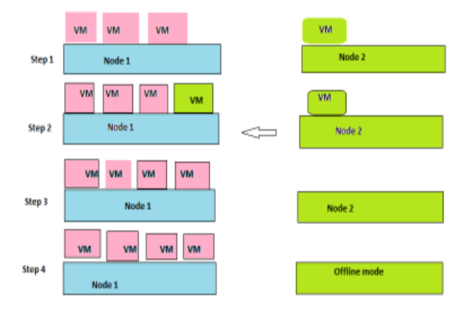
Fig1: Working of Live Migration

The above diagram shows the live virtual machine migration. Initially three VM working on node 1 and one VM working on node2. Migrations allow the movement of VM from node 2 to node 1. The key challenges in the live virtual machine migrations are minimal service downtime and total migration time. The migration techniques can be broadly classified in to below types.

a. Pre-copy: memory state is migrated in bulk from source node to target node even as the VM is in executing phase at source node. In mean time changes in memory data has been recorded this is known as dirtied pages. If any dirtied pages has been transmitted, it will be again sent to the target node in the next round. The copying of dirtied pages will continues until certain number of prefixed rounds is reached. This signals the phase end of memory transfer and beginning the phase of service downtime. Now the VM will be suspended on the source node, its processor state and remaining dirtied pages will be transferred to the destination node. Hence, it completes the migration process. Now the virtual machine restarts and copy at source node is deleted. The diagram represented by figure 1 shows the steps in the pre copy approach.

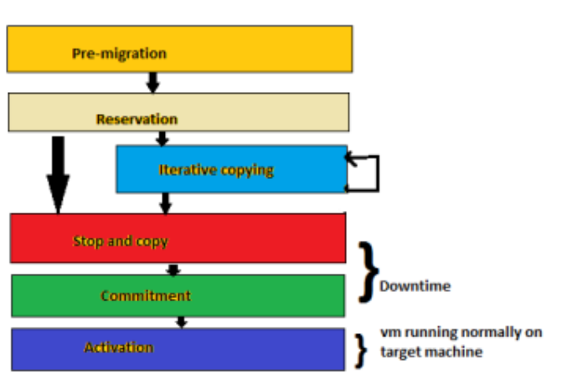
Fig2: Steps for pre-copy approach

- b. Post-copy: maintains the processor state of VM during the migration process. Memory pages that are faulted in to the memory and not yet pushed are demand-paged over the network from source machine. In this approach, memory pages are transferred at most once. Post-copy improves metrics like total migration time, network overhead and pages transferred. The four mechanisms included in post-copy are Active push, Demand-paging, Pre-paging and Dynamic self-ballooning (DSB).

- Demand paging ensures that each page is transferred only once to target node. Active Push removes the dependencies from source node as quickly as possible. In post-copy all the pages will be transferred only once and DSB used for handling free pages.

- c. Memory Management: plays a vital role in migration of virtual machines because it affects the performance of the migration process if it consumes more energy. Memory management based live migration can be classified in to different categories by considering the nature of operation used for reducing the amount of data transfer. As Memory compression based mechanisms, Memory re-use based mechanism and Memory pruning based mechanism.

- d. Network Aware: An approach to minimize the data transfer time in time-intensive applications due to network I/O performance considering network conditions between the physical machines and data storage. It also consider varied data access due to instable network condition. Network aware migration can be classified as Topology based mechanisms, transparent migration based Mechanism and Network paging based mechanism.

e. Energy Management: If sufficient measures are not accounted while migration may result in more energy consumption and therefore leading to high cost. Energy consumption aware mechanisms, Load aggregation based mechanism, Application placement based mechanism and Workload adaptive mechanism Security Aware.

f. Application Specific: Live migration can also be performed on applications that are specific to customer needs. It can be classified as Multitier and I/O intensive on nature of applications.

g. Business aware: Live Migration must account the benefits from consumer and service provider perspective. It should utilize the mechanisms that limit migration cost without affecting service performance. Business aware can be classified as Cost aware mechanisms and QoS aware mechanism.

- Virtual Machine Migration to Multiple Hosts
In this module, we will discuss about virtual machine migration via multicast (one-to-many) approaches.
The migration process must be transparent to the application running on top of VM’s and operating systems. When migrating virtual machine from one-to-many hosts we require the identification, grouping and transferring of pages: unique pages, identical pages, dirtied pages and pages that are lost during transfer. While the identification and transferring of unique pages from one-to-one host is uncomplicated process, on the other hand transfer of identical pages is complicated due to conglomerate (i.e. association) among pages .The identical pages can be classified into two categories Firstly, self-identical which means existing in only one VM and secondly, inter-identical which means existing on multiple VM’s or may target one or more hosts .The transfer of identical pages fall in three categories:

a. Identical pages Single VM single Target (ISVST): Identical pages belong to category of self-identical (i.e. pages exist on only one VM), hence transferring require only one copy of identical pages to be moved from a source to a target host (one-to-one), also called unicast approach. This reduces network and data traffic.
- b. Identical pages Multiple VM single Target (ISMVST): Identical pages belong to category of inter-identical (i.e. pages exist on multiple VMs), hence transferring requires multiple copies of pages to be moved from multiple sources to a single target host (many-to-one) .It also reduces network and data traffic.

- C. Identical pages multiple VM multiple Target (ISMVMT): Identical pages belong to category of inter-identical (i.e. pages exist on multiple VMs), hence transferring requires multiple copies of pages to be moved from multiple sources to multiple target hosts .Is it many-to-many?? No, as grouping of identical pages takes at source host and then multicast approach (one-to-many) is used to deliver identical pages to group of destination simultaneously in a single transmission via TCP/UDP. This mechanism reduces the possibility of transferring each page individually .Hence it reduces transferred data along with network and data traffic.

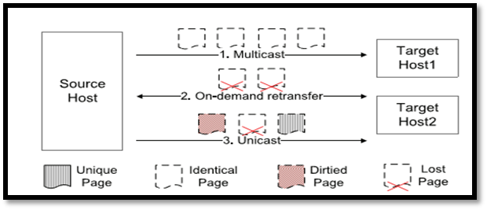
Fig 1.Three stages of page transfer

The unique and dirtied pages are transferred through unicast approach to target machine, whereas identical pages by either unicast or multicast depending whether it is ISVST, ISMVST, ISMVMT. The packet transferred in either approach carry information about the page and target host for which it is destined (same as Paging in Virtual Memory). Every packet has three fields associated with it: Virtual Machine Id, Guest Physical address (GPA), Page Content (PG).VM id may be ID of target host or its MAC address. GPA determine the memory position that will be acquired by page. PG records the full content of page.

  - VMscatter Architecture
In the traditional approach, live VM migration used techniques such as pre-copy, post-copy and log-replay. In these techniques, VM’s pages are transferred between Migration Managers at source and destination hosts through a direct TCP connection. Both the pre-copy and post-copy minimize migration time and provide better performance with low bandwidth in “one-to-one” live migration. While in “one-to-many” live VM migration, it uses VMscatter approach using QEMU/KVM. Quick Emulator (QEMU) is a fast and portable dynamic translator or virtualization device, emulates CPU through binary translation, in order to run unmodified operating systems for different machine architectures. But processing power of QEMU for communication between Virtual Machine CPU and host machines CPU is extremely low. So there is a need to use accelerator, called as Kernel Virtual Machine (KVM). It provides protection while virtualizing guest operating systems. VMscatter has a scheduler, a collector, and migration senders at source host and a migration receiver at destination host. The process works as follows in VMscatter architecture:-

- Initially (Set-Up Stage), VM make a system call “madvise”, which inform the collector to collect and organize identical pages in virtual memory address range, which is actually physical memory address with respect to the viewpoint of VM.
- Secondly (Memory Transfer Stage), there is one-to-one mapping between physical address of VM to virtual address of physical host.
- Thirdly (Storage Transfer Stage), Kernel mode Collector transfers metadata (VM ids and page address) about identical pages from kernel to Quick emulator via ioctl system call (input/output control).Ioctl provides a conventional way to bridge user-space code to kernel extensions. Migration Sender access this user-space code
- Fourthly, Scheduler uses efficient greedy algorithm (as described below) to determine the placement of VM’s on the destination side.
- Finally, data transfer takes place between migration sender and receiver. Sender keep on dispatching pages until receivers in destination hosts obtain consistent state of associated VM’s with that of source host.

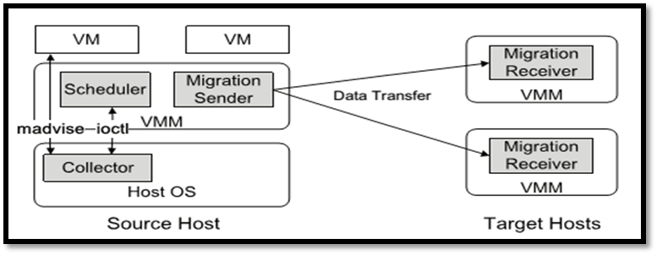
Fig 2. VMscatter Architecture

*Greedy Algorithm decides which target host should be selected for placement of VM’s on the destination host. It fills the destination host which has maximal capacity, then fills host with second greater capacity, and repeat this process until destinations are filled by all the n VM’s.

5.2 Scatter-Gather Live VM Migration
In conventional live migration approach (VMscatter) as discussed above, the source transfers the VM’s state to destination host through a direct TCP connection which carries control information, data regarding VM’s memory and CPU state. However, a TCP connection doesn’t last for a long time, connection last until destination receives the entire VM.

In present live migration approach (Scatter-Gather), source and destination exchange vast amount of VM’s memory through intermediate sites A1, A2……..AN. However, some control information about demand-paged memory or CPU execution state is still exchanged by using TCP connection, which lasts only till source evicts entire VM. Similar to conventional approach KVM/QEMU are used as Migration Managers on both sides (source and destination), whereas Virtualized Memory Device (VMD) will be used as a mediator. VMD layer accumulates the free blocks of physical memory from all the intermediate sites or nodes, and then present the compiled data to Migration Managers at sender and receiving hosts (MS, MD). As the name suggest, Scatter-Gather has two phases:

Scatter Phase In order to reduce total eviction time, we use scatter phase .It quickly evicts memory and execution state from source host. It establishes controlled TCP connection between sender and receiver, and transfers CPU state to receiving host so that VM is resumed immediately. VM at destination host would generate page-faults for every page not available in physical memory because main memory resides at the source host. The migration manager’s (MS, MD) exchange information about page-faults and then MS responds with faulted page, similar to demand-paging concept. However, this process is terribly slow.

There is need to speed up eviction of memory at source host, therefore we transfer VM’s pages from source host to intermediate host (Ai’s). MS exports memory pages to files sequentially .The files are passed on to the Virtual memory device layer. VMD layer distributes or scatters pages over network to intermediate hosts .The control information containing address of each page which was scattered and its status (deduplication or compression applied to each page), is sent to destination’s manager over TCP connection. The MD use this information to gather VM pages from VMD layer. Therefore, once entire memory has been evicted to virtual memory layer, source can be deprovisioned.

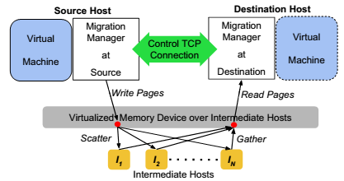
Fig. 3 Scatter-gather VM Migration

Gather Phase: It gathers pages from intermediate nodes and source host. It consist of performing demand –paging and pre-paging concurrently in different threads with minimum interference. In demand-paging, MS gives higher priority to faulted page than to a page being scattered over device layer, on the grounds that it reduces latency of servicing page faults. The request for demand paging are sent to the source host, which then sends the requested page over TCP connection. On the other hand, pre-paging consist of copying the received pages into the VM’s memory using per-page control information. Thus, this ensures destination reads every page from VMD only after it has been written to VMD by source.

  - Off-the-shelf Migration
The commercial off-the-shelf (COTS) live migration approach method is used in KVM/QEMU (Kernel Virtual Machine/Quick Emulator) without optimization. This consist compression of pages who have exactly same bytes, similar to zero-aware compression algorithm.

- Live Migration with resource reservation

In this module , we will discuss Live migration with resource management .It consists of four modules Resource Reservation Controller (RC), Migration Decision-Maker (MDC), Migration Controller (MC), and Resource Monitor (RM).
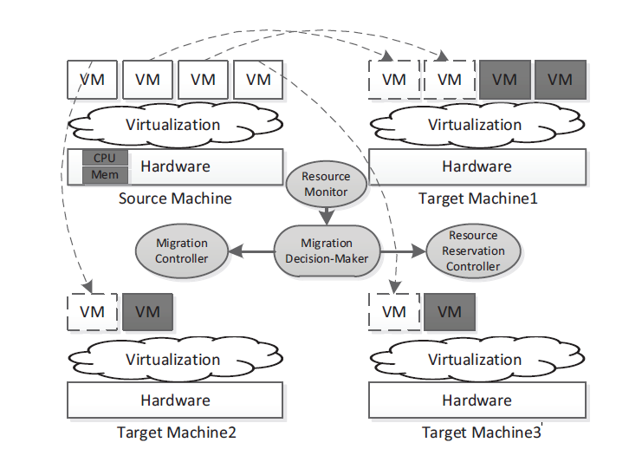
Fig Live Migration via Resource Reservation Technology
Migration Decision-Maker: is the vital player in the migration of multiple VM. This helps in effective migration decision. Its quality can be reflected from migration strategies used. This module can also make efficient strategies by using machine vision on historical data.

Migration Controller: this controls the real migration process. Migration controller depends on migration decision maker and executes the strategies decided by it. This will select the right target node from target node list and initiate the migration at particular time.

Resource Reservation Controller: this helps in implementing various resource reservation strategies for source node and target node. Such as memory and CPU resource in the source node or in target node. This module has a high importance to void migration failures due to insufficient resources in the target node. In source machine the resource are allocated by dynamically adjusting CPU cycle and memory resource of migrated virtual machine. And in target machine the resource reservation is done by temporarily creating a virtual machine for occupying certain number of resources.

Resource Monitor: it helps in monitoring the resource status from both source node and target node. It also helps in analyzing the workload stability to avoid migration thrashing.

The Resource Reservation Methods: the resource reservation methods needs to implement in both source and target node. The reserved resource in target node includes whole virtual machine resources and in source node it includes CPU and memory.
The Resource Reservation Methods

Resource Reservation in Source Machine: this process consumes some of the resources from the source node. Migration performance can be improved by dynamically controlling the system resources. CPU resource reservation can be made by adjusting the CAP value (i.e. to limit the maximum utilization) and the memory resource can be reserved by adjusting the size of virtual machine dynamically.

Resource Reservation in Target Machine: Availability of resource on target node may affect the migration process. Memory resource reservation is made by creating virtual machines with specific amount of memory. These virtual machines are shut down for vacating system resources for the migrated virtual machines. If the migration fails due to insufficient resources then resource reservation will untie the physical machine from candidate target nodes. And another target node will be selected from list for migration

- Performance Measurement
We evaluate live virtual migration in multicast approach on basis of following performance components:

7.1 Total Migration Time: In this we will compare, total migration time in two modes i.e. VMscatter, Off-the-Shelf Live Migration. We migrate n VM’s where n is number virtual machine, using experimental setup. We discovered that VMscatter has least total migration time ,it can migrate 12 VM’s (n=12) in 32.7 seconds whereas off-the-shelf method requires 105 seconds .This can be stated as 69.1% reduction in migration time due to aspect that pages that were identical are shifted by a single copy. Hence it reduces IO overhead and transferred data.

7.2 Total transferred data: In this we will compare, total transferred data in three modes i.e. VMscatter, Scatter-Gather and Off-the-Shelf Live Migration. VMscatter can transfer fewer data as compared to off-the-shelf method as it uses zero-aware compression technique to compress pages during transmission. VMscatter reduces amount of transferred data to 74.2% due to transmission of accumulated duplicated pages. Hence it reduces time consumption for transferring between physical hosts.

- Future Work
In near future we will alleviate the security issue in live migration through VMM enforced process protection.

- Conclusion
Live virtual migration is moving a virtual machine from physical host to other. This is an efficient technique for implementing energy saving and load balancing. In this paper we have discussed various techniques for migrating virtual machines such as live migration via unicast and multicast. In unicast we described pre copy, post copy, memory management, network aware, energy management, application specific and business aware applications. In Multicast approach we have live migration via multicast, VMscatter, Scatter gather live migration and off the shell live migration. Then in cloud computing resource reservation is described. The approaches described for unicast are able to fulfill metrics like performance, energy consumption and cost based on user need. In case of VMscatter there is large reduction in total migration time and total amount of transferred data as compared to traditional live migration approaches (Quick Emulator/Kernel virtual machine). In scatter gather live migration main objective is to reduce Vm eviction time which can be achieved by decoupling the source and destination host during migration and scattering memory pages to multiple intermediate nodes and finally gathering these pages to reduce latency. In resource reservation migration can be used in target node to avoid migration failures.

- References

[1] Lei Cui, Jianxin Li, Bo Li, Jinpeng Huai, Chunming Hu, Tianyu Wo, Hussain Al-Aqrabi, and Lu Liu. 2013. VMScatter: migrate virtual machines to many hosts. In Proceedings of the 9th ACM SIGPLAN/SIGOPS international conference on Virtual execution environments (VEE '13). ACM, New York, NY, USA, 63-72. DOI=http://dx.doi.org/10.1145/2451512.2451528

[2]Deshpande, U.; Yang You; Chan, D.; Bila, N.; Gopalan, K., "Fast Server Deprovisioning through Scatter-Gather Live Migration of Virtual Machines," in Cloud Computing (CLOUD), 2014 IEEE 7th International Conference on , vol., no., pp.376-383, June 27 2014-July 2 2014

[3]Sallam, Ahmed, and Kenli Li. 2014. A Multi-objective Virtual Machine Migration Policy in Cloud Systems. The Computer Journal. 57, no. 2: 195

[4]Hai Jin; Li Deng; Song Wu; Xuanhua Shi; Xiaodong Pan, "Live virtual machine migration with adaptive, memory compression," in Cluster Computing and Workshops, 2009. CLUSTER '09. IEEE International Conference on, vol., no., pp.1-10, Aug. 31 2009-Sept. 4 2009

[5]Guthrie, Forbes, and Scott Lowe. 2013. VMware VSphere Design. Indianapolis, Indiana: John Wiley and Sons.

[6]https://pubs.vmware.com/vsphere51/index.jsp#com.vmware.vsphere.vcenterhost.doc/GUID-ED375B12-7D08-4B7E-81EE-DCE83E51B1AF.html

[7]https://docs.oracle.com/cd/E50245_01/E50249/html/vmcon-vm-move.html

[8]https://www.vmware.com/products/vsphere/features/vmotion

[9] Acharya, S.; D'Mello, D.A., "A taxonomy of Live Virtual Machine (VM) Migration mechanisms in cloud computing environment," in Green Computing, Communication and Conservation of Energy (ICGCE), 2013 International Conference on , vol., no., pp.809-815, 12-14 Dec. 2013.

[10] Sharma, S.; Chawla, M., "A Technical Review for Efficient Virtual Machine Migration," in Cloud & Ubiquitous Computing & Emerging Technologies (CUBE), 2013 International Conference on , vol., no., pp.20-25, 15-16 Nov. 2013.

[11] Kapil, D.; Pilli, E.S.; Joshi, R.C., "Live virtual machine migration techniques: Survey and research challenges," in Advance Computing Conference (IACC), 2013 IEEE 3rd International , vol., no., pp.963-969, 22-23 Feb. 2013.

[12] Kejiang Ye; Xiaohong Jiang; Dawei Huang; Jianhai Chen; Bei Wang, "Live Migration of Multiple Virtual Machines with Resource Reservation in Cloud Computing Environments," in Cloud Computing (CLOUD), 2011 IEEE International Conference on , vol., no., pp.267-274, 4-9 July 2011

[13] Rakhi k Raj and Getzi Jeba Leelipushpam., ―Live Virtual Machine Migration Techniques – A Survey‖, International Journal of Engineering Research and Technology, Volume 1 Issue 7, September 2012.
[14] C. Clark, K. Fraser, S. Hand, J. G. Hansen, E. Jul, C. Limpach ,I. Pratt, and A. Warfield. Live migration of virtual machines. In Proceedings of NSDI, pages 273–286, 2005.

[15] https://docs.oracle.com/cd/E26996_01/ E18549/html/VMUSG1010.html

[16] Hines, M., Deshpande, U., & Gopalan, K.2009). “Post-copy live migration of virtual machines.”, ACM SIGOPS operating system reviews,43(3), 14-26.

